(Approx. 439 words)

Using Virtual Operating Systems
Bob Elgines, Editor, Colorado River Computer Club (CRCC)
www.crccaz.org
elginesz (at) hotmail.com

If you have Windows 7 Pro or better you can use Microsoft’s free Virtual Program and a free Windows XP copy. If not, or you wish to add more than one Virtual Disk Drive, then use the free Oracle Virtual Program. Of course you will need the OS (Operating System) disk you wish to load, such as Win XP, Lynx, etc.

After installing the Oracle program double click on it and the Oracle VM (Virtual Manager) welcome window comes up.

- Click on NEW (located in the upper left), then NEXT
- Put in a Name of the OS, such as LYNX, then NEXT
- Select memory size needed for your Virtual Drive, such as 512MB for Lynx or Win XP, and 1000 MB for Vista. Click NEXT
- Select “Create New Hard Disk”, then NEXT
- Select “VDI”, then NEXT
- Select “Dynamically allocated”, then NEXT
- Set 8 to 20 GB for hard drive space depending on OS. Example 10 for Lynx and XP, 20 for Vista, then NEXT
- SUMMARY is listed, if good, then click on CREATE
- The “Oracle Virtual Manager” window comes up. You are almost ready for installing your OS, double click on the listing of OS you just created (upper left).
- Your Host drive is now shown (usually Drive D:). Install your OS installation disk (CD or DVD), an “Auto play” window comes up, X it out, then click on NEXT
- Another Summary, click on START, your OS starts to install. Follow instructions on the screen.

After installation of the OS you may want to install your own Antivirus program if you are going to us it on the web.

If the Internet does not work you may have to change the settings on the VM windows under Internet. Most common setting are: attached to: NAT; and Adapter Type: Intel Pro / 1000 MT (Desktop). Try different Adapter types first.
These worked fine for XP and Lynx.

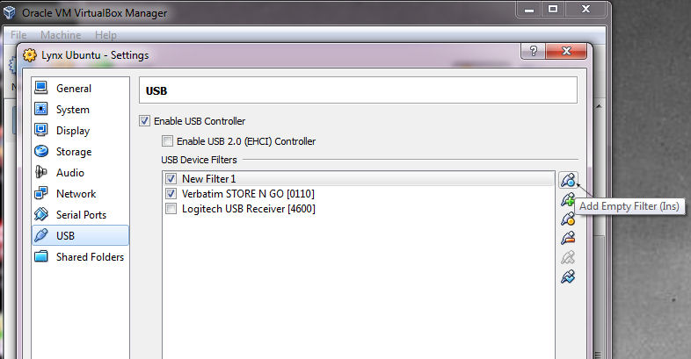
To setup the USB for reading thumb drives, etc. First plug in a Thumb Drive. Second bring up Oracle VM and on the lower right double click on USB. The USB screen comes up, then click on “Add Empty Filter”, symbol located on the right, next click on the “+” symbol, if your thumb drive is listed, then select it. Now click on the “+” again and select your mouse (using a USB Mouse) on the list, then take the check mark off. In the picture is “Store & Go” for Thumb Drive and “Logitech” for Mouse. 

